Immanuel Lutheran Church
2416 Jefferson Park Avenue
Charlottesville, VA 22903
(434) 295-4038
ilc.avenue.org

Pastor Ben Maton

Music Director Eric Franzen

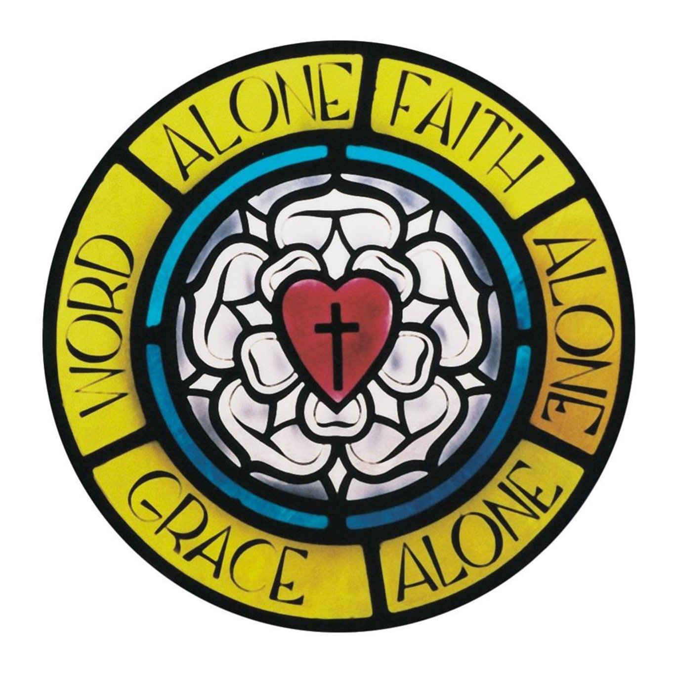

Twelfth Sunday after Pentecost

August 16, 2026
Good News—Holy Communion is celebrated at Immanuel today! God loves you! He loves most of all to give you His gifts and today the Risen Jesus comes to give Himself to you in His sacred meal. Because nothing breaks God’s heart more than to see His children miss out on His gifts, it is our heartfelt prayer and God’s deep desire that, as you prepare to receive Him, you give your joyful “Amen!” to these statements:
- I have been baptized in the name of the one true God: Father, Son, and Holy Spirit. Matthew 28:18-20
- I am a sinner in need of God’s forgiveness and am sorry for my sins. 1 John 1:8-9
- I believe that Jesus Christ is my only Savior from sin, death, and the power of the devil. Ephesians 2:4-9
- I believe that the body and blood of Jesus Christ—given and shed for the forgiveness of my sins—are truly present for me with the bread and wine of Holy Communion. Matthew 26:26-28
- As one who lives by God’s forgiveness alone, I strive to live at peace with others and withhold forgiveness from no one. Matthew 5:23-24
At the appropriate time, the ushers will direct forward those wishing to commune. Communicants receive our Lord’s body from pastor and then may choose to receive His blood from either the small cups or the common chalice. Used small cups should be placed in the wicker basket near the front pew. Those who cannot assent to the above statements or otherwise do not wish to commune may come forward for a blessing with arms folded across the chest. Please speak with pastor about communion preparation for young children or should you have any questions about our teaching or practice surrounding Holy Communion.

Jesu Juva!

Divine Service IV
Lutheran Service Book, pp. 203ff.

Stand to face the cross

Processional Hymn All Ye Weary and Distressed
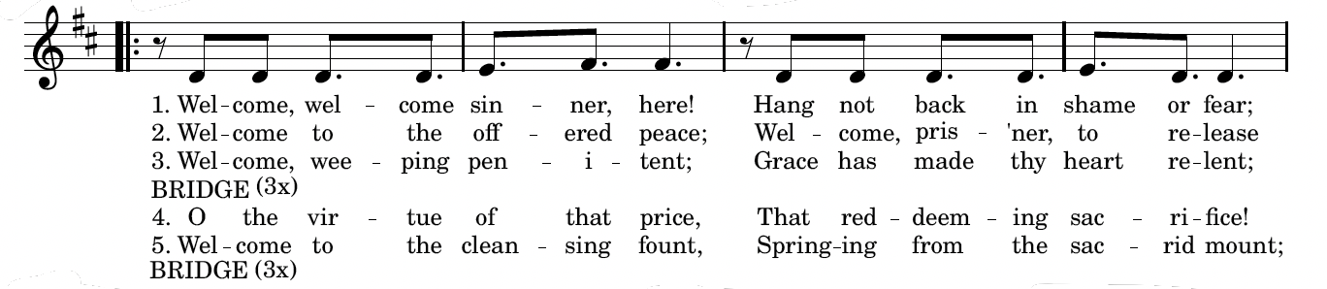
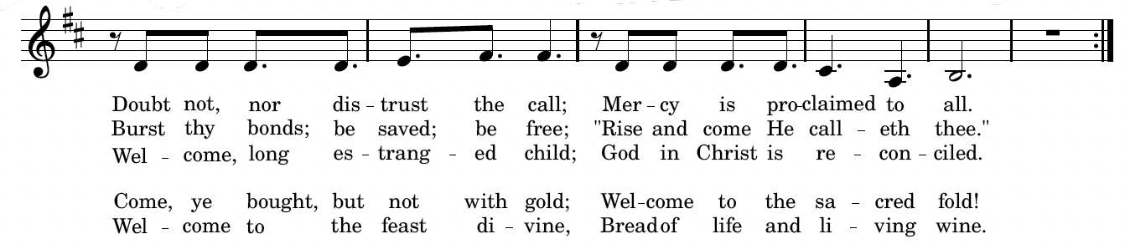
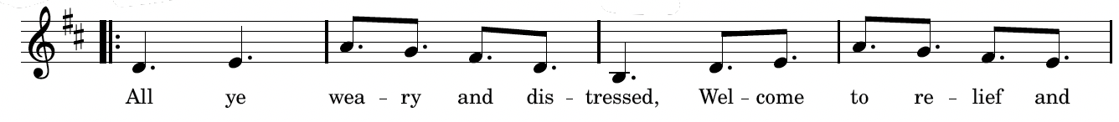
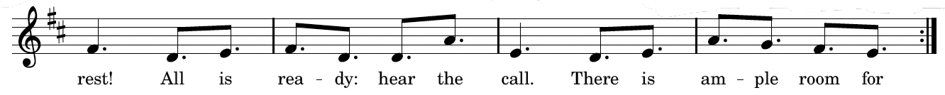
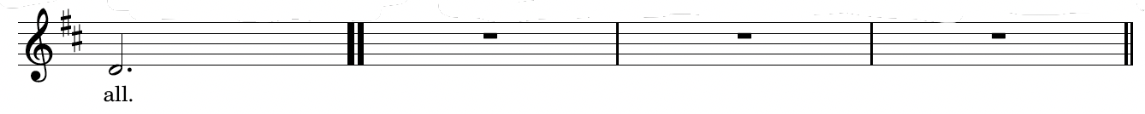

Invocation, Confession & Absolution

The sign of the cross may be made by all in remembrance of their Baptism.

P In the name of the Father and of the T Son and of the Holy Spirit.
C Amen.

P Our help is in the name of the Lord,
C who made heaven and earth.
P If You, O Lord, kept a record of sins, O Lord, who could stand?
C But with You there is forgiveness; therefore You are feared.

P Since we are gathered to hear God’s Word, call upon Him in prayer and praise, and receive the body and blood of our Lord Jesus Christ in the fellowship of this altar, let us first consider our unworthiness and confess before God and one another that we have sinned in thought, word, and deed, and that we cannot free ourselves from our sinful condition. Together as His people let us take refuge in the infinite mercy of God, our heavenly Father, seeking His grace for the sake of Christ, and saying:
C God, be merciful to me, a sinner. Almighty God, have mercy upon us, forgive us our sins, and lead us to everlasting life. Amen.
P Almighty God in His mercy has given His Son to die for you and for His sake forgives you all your sins. As a called and ordained servant of Christ, and by His authority, I therefore forgive you all your sins in the name of the Father and of the T Son and of the Holy Spirit.
C Amen.

Introit Psalm 28:1–2, 6–7; antiphon: v. 8
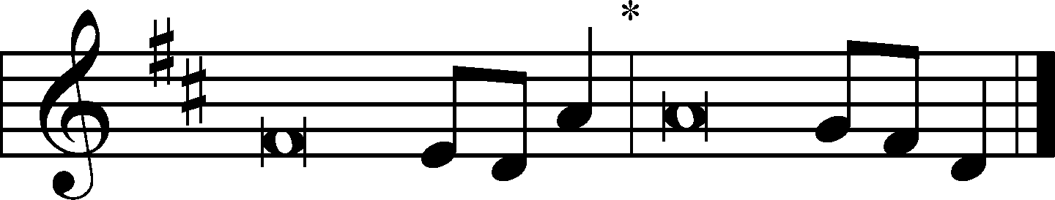
A The Lord is the strength of his | people;* he is the saving refuge of his a- | nointed.
C To you, O Lord, I call; my rock, be not | deaf to me,*
lest, if you be silent to me, I become like those who go down | to the pit.
A Hear the voice of my pleas for mercy, when I cry to | you for help,*
when I lift up my hands toward your most holy sanctu- | ary.
C Blessèd | be the Lord!* For he has heard the voice of my pleas for | mercy.
A The Lord is my strength and my shield; in him my heart trusts, and | I am helped;*
my heart exults, and with my song I give | thanks to him.
All: Glory be to the Father and | to the Son* and to the Holy | Spirit;
as it was in the be- | ginning,* is now, and will be forever. | Amen.
A The Lord is the strength of his | people;* he is the saving refuge of his a- | nointed.

Service of the Word
Kyrie

A For the peace from above and for our salvation, let us pray to the Lord.
C Lord, have mercy; Christ, have mercy; Lord, have mercy.
A For the peace of the whole world, for the well-being of the Church of God, and for the unity of all, let us pray to the Lord.
C Lord, have mercy; Christ, have mercy; Lord, have mercy.
A For this holy house and for all who offer here their worship and praise, let us pray to the Lord.
C Lord, have mercy; Christ, have mercy; Lord, have mercy.
A Help, save, comfort, and defend us gracious Lord.
C Lord, have mercy; Christ, have mercy; Lord, have mercy.

Gloria in Excelsis LSB 204
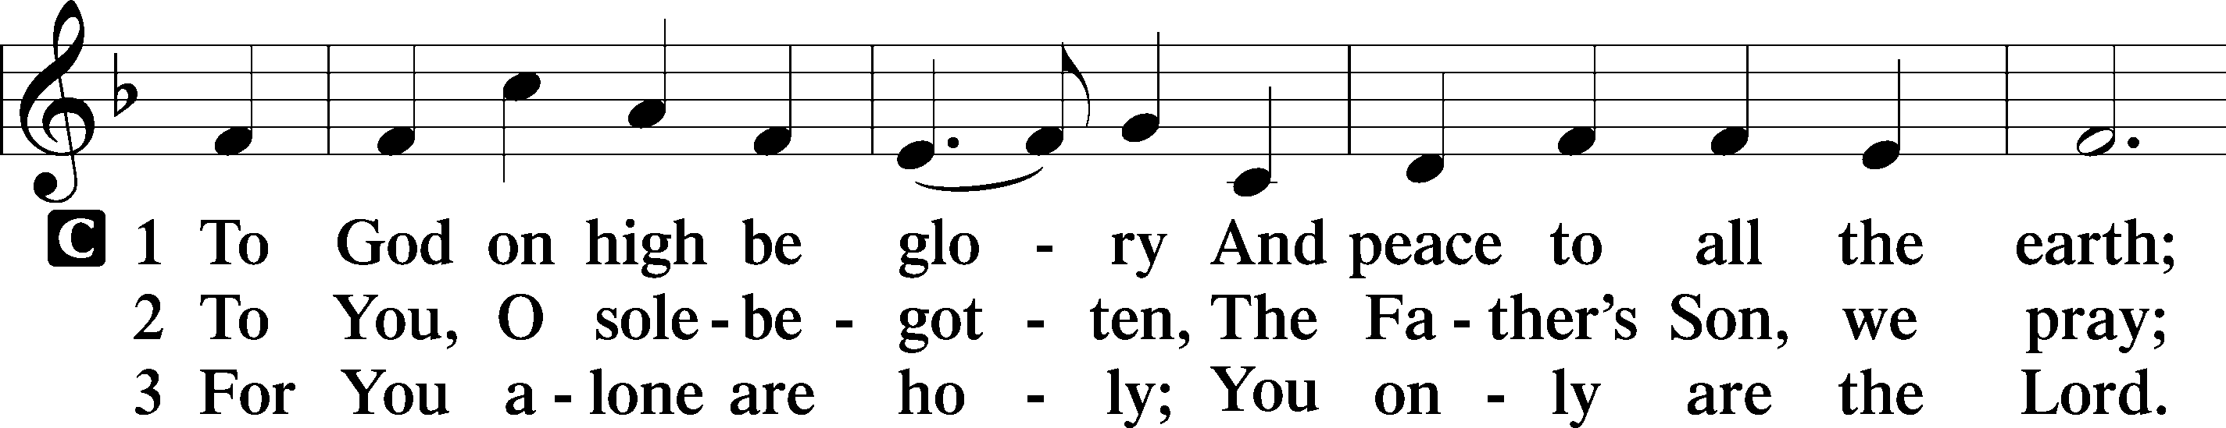
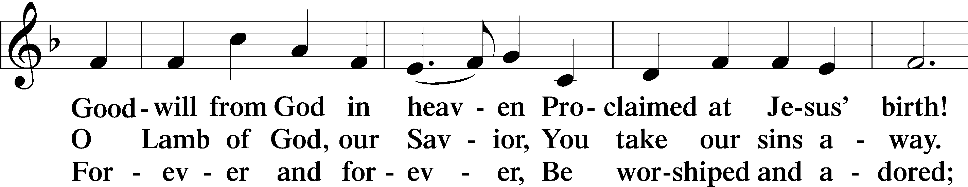
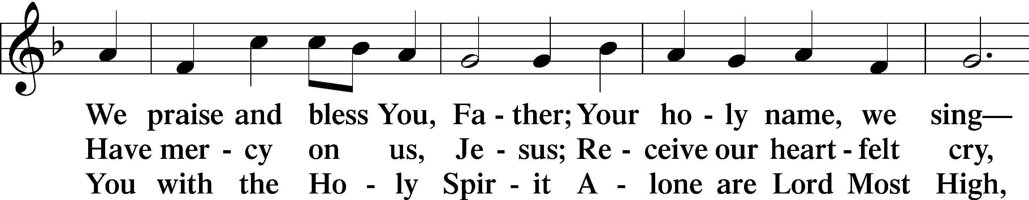
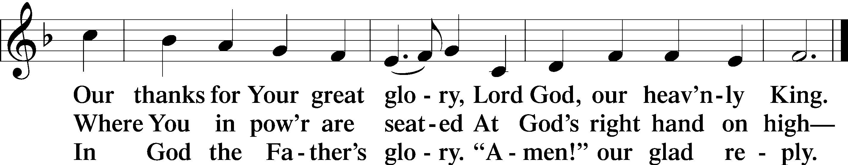

Salutation and Collect of the Day
P The Lord be with you.
C And also with you.

P Let us pray. Almighty and everlasting Father, You give Your children many blessings even though we are undeserving. In every trial and temptation grant us steadfast confidence in Your loving-kindness and mercy; through Jesus Christ, Your Son, our Lord, who lives and reigns with You and the Holy Spirit, one God, now and forever.

C Amen.

Sit

Old Testament Reading Isaiah 56:1–8
¹Thus says the Lord: “Keep justice, and do righteousness, for soon my salvation will come, and my deliverance be revealed ²Blessed is the man who does this, and the son of man who holds it fast, who keeps the Sabbath, not profaning it and keeps his hand from doing any evil.” ³Let not the foreigner who is joined to the Lord say, “The Lord will surely separate me from his people”; and let not the eunuch say, “Behold, I am a dry tree.” ⁴For thus says the Lord: “To the eunuchs who keep my Sabbaths, who choose the things that please me and hold fast my covenant, ⁵I will give in my house and within my walls a monument and a name better than sons and daughters; I will give them an everlasting name that shall not be cut off. ⁶“And the foreigners who join themselves to the Lord, to minister to him, to love the name of the Lord, and to be his servants, everyone who keeps the Sabbath and does not profane it, and holds fast my covenant—⁷these I will bring to my holy mountain, and make them joyful in my house of prayer; their burnt offerings and their sacrifices will be accepted on my altar; for my house shall be called a house of prayer for all peoples.” ⁸The Lord God, who gathers the outcasts of Israel, declares, “I will gather yet others to him besides those already gathered.”

A This is the Word of the Lord.
C Thanks be to God.

Gradual (Cantor) Psalm 34:9, 19, alt.
Fear the Lord, | you his saints,*for those who fear him lack | nothing!
Many are the afflictions of the | righteous,*but the Lord delivers him out | of them all.

Epistle Romans 11:1–2a, 13–15, 28–32
¹I ask, then, has God rejected his people? By no means! For I myself am an Israelite, a descendant of Abraham, a member of the tribe of Benjamin. ²God has not rejected his people whom he foreknew. . . . ¹³Now I am speaking to you Gentiles. Inasmuch then as I am an apostle to the Gentiles, I magnify my ministry ¹⁴in order somehow to make my fellow Jews jealous, and thus save some of them. ¹⁵For if their rejection means the reconciliation of the world, what will their acceptance mean but life from the dead? . . . ²⁸As regards the gospel, they are enemies of God for your sake. But as regards election, they are beloved for the sake of their forefathers. ²⁹For the gifts and the calling of God are irrevocable. ³⁰Just as you were at one time disobedient to God but now have received mercy because of their disobedience, ³¹so they too have now been disobedient in order that by the mercy shown to you they also may now receive mercy. ³²For God has consigned all to disobedience, that he may have mercy on all.

A This is the Word of the Lord.
C Thanks be to God.

Stand

Alleluia and Verse LSB 205
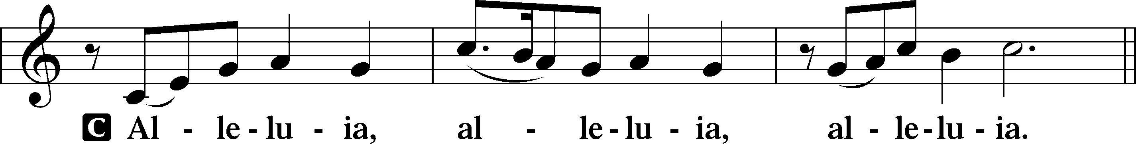
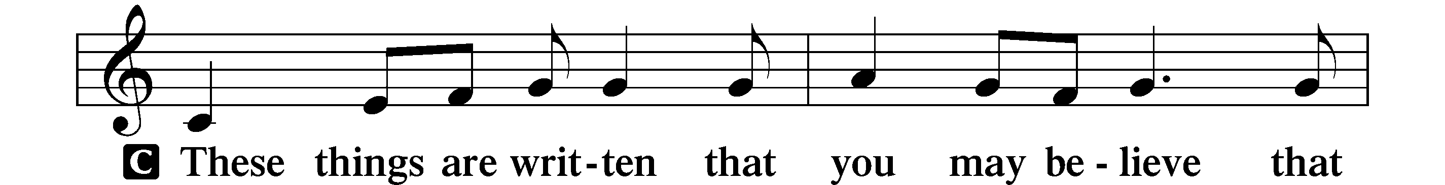
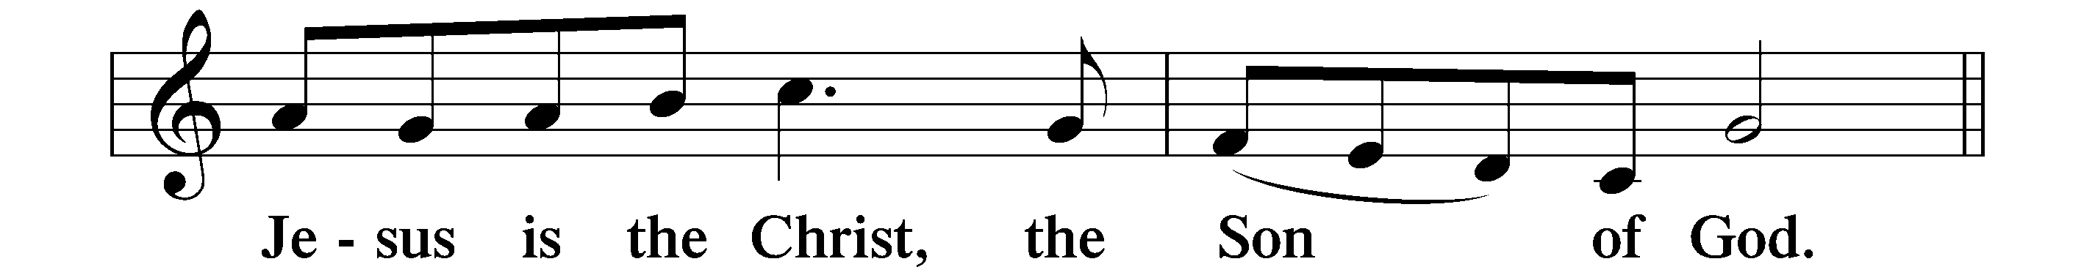
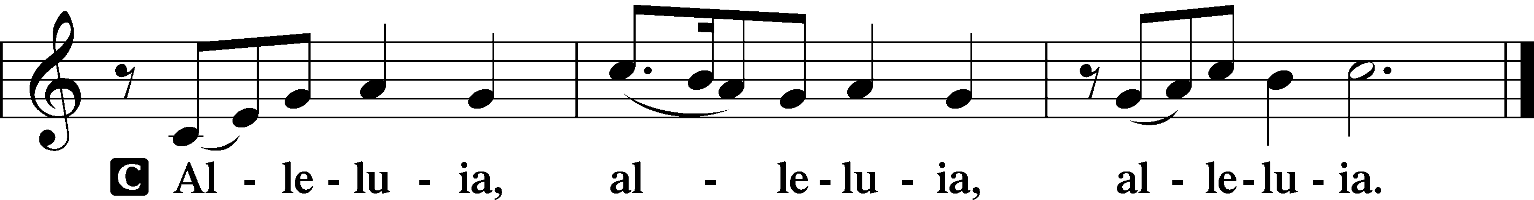

Holy Gospel Matthew 15:21–28
P The Holy Gospel according to St. Matthew, the fifteenth chapter.
C Glory to You, O Lord.

²¹Jesus went away from there and withdrew to the district of Tyre and Sidon. ²²And behold, a Canaanite woman from that region came out and was crying, “Have mercy on me, O Lord, Son of David; my daughter is severely oppressed by a demon.” ²³But he did not answer her a word. And his disciples came and begged him, saying, “Send her away, for she is crying out after us.” ²⁴He answered, “I was sent only to the lost sheep of the house of Israel.” ²⁵But she came and knelt before him, saying, “Lord, help me.” ²⁶And he answered, “It is not right to take the children’s bread and throw it to the dogs.” ²⁷She said, “Yes, Lord, yet even the dogs eat the crumbs that fall from their masters’ table.” ²⁸Then Jesus answered her, “O woman, great is your faith! Be it done for you as you desire.” And her daughter was healed instantly.

P This is the Gospel of the Lord.
C Praise to You, O Christ.

Sit

Children’s Message

Hymn of the Day How Wide the Love of Christ LSB 535

Sermon

Stand

Credo (Nicene Creed)
All: I believe in one God, the Father Almighty, maker of heaven and earth and of all things visible and invisible. And in one Lord Jesus Christ, the only-begotten Son of God, begotten of His Father before all worlds, God of God, Light of Light, very God of very God, begotten, not made, being of one substance with the Father, by whom all things were made; who for us men and for our salvation came down from heaven and was incarnate by the Holy Spirit of the virgin Mary and was made man; and was crucified also for us under Pontius Pilate. He suffered and was buried. And the third day He rose again according to the Scriptures and ascended into heaven and sits at the right hand of the Father. And He will come again with glory to judge both the living and the dead, whose kingdom will have no end. And I believe in the Holy Spirit, the Lord and Giver of life, who proceeds from the Father and the Son, who with the Father and the Son together is worshiped and glorified, who spoke by the prophets. And I believe in one holy Christian and apostolic Church, I acknowledge one Baptism for the remission of sins, and I look for the resurrection of the dead and the life T of the world to come. Amen.

Prayer of the Church

Following the prayers, the people may greet one another in the name of the Lord, saying, “Peace be with you,” as a sign of reconciliation and of the unity of the Spirit in the bond of peace (Matt. 5:22–24; Eph. 4:1–3).
Sit

Offering & Offertory (please stand to sing as offerings are brought forward)

Create in Me a Clean Heart

Service of the Sacrament

Preface LSB 208
P The Lord be with you.
C And also with you.
P Lift up your hearts.
C We lift them to the Lord.
P Let us give thanks to the Lord our God.
C It is right to give Him thanks and praise.
P It is truly good, right, and salutary that we should at all times and in all places give thanks to You, holy Lord, almighty Father, everlasting God, through Jesus Christ, our Lord, who, having created all things, took on human flesh and was born of the virgin Mary. For our sake He died on the cross and rose from the dead to put an end to death, thus fulfilling Your will and gaining for You a holy people. Therefore with angels and archangels and with all the company of heaven we laud and magnify Your glorious name, evermore praising You and saying:

Sanctus LSB 208
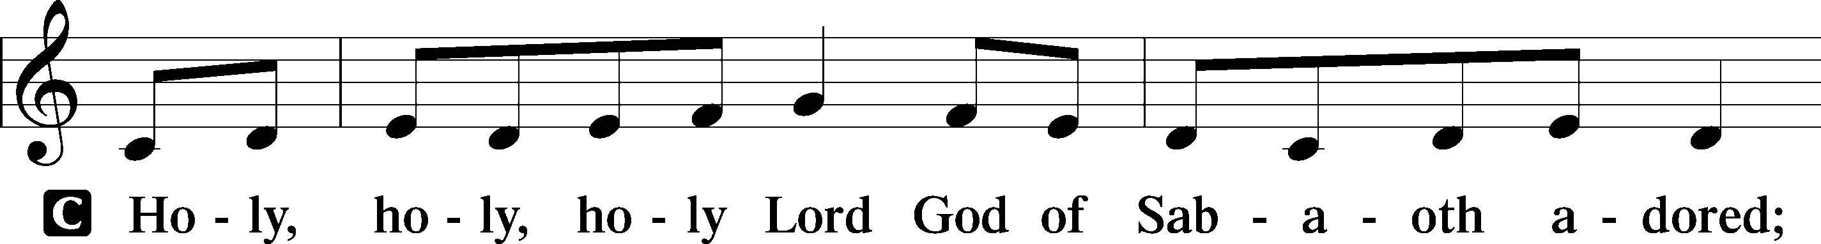
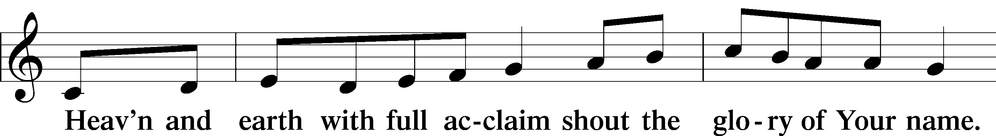
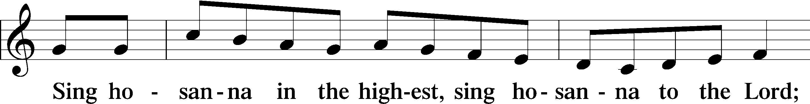
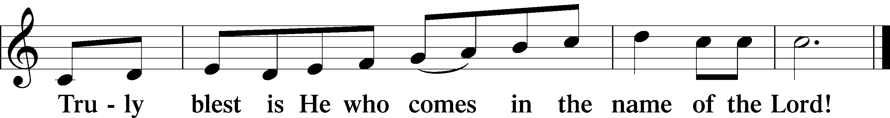

The Words of Our Lord
P Our Lord Jesus Christ, on the night when He was betrayed, took bread, and when He had given thanks, He broke it and gave it to the disciples and said: “Take, eat; this is My T body, which is given for you. This do in remembrance of Me.”

In the same way also He took the cup after supper, and when He had given thanks, He gave it to them, saying: “Drink of it, all of you; this cup is the new testament in My T blood, which is shed for you for the forgiveness of sins. This do, as often as you drink it, in remembrance of Me.”

Proclamation of Christ
P As often as we eat this bread and drink this cup, we proclaim the Lord’s death until He comes.
C Amen. Come, Lord Jesus.
P O Lord Jesus Christ, only Son of the Father, in giving us Your body and blood to eat and to drink, You lead us to remember and confess Your holy cross and passion, Your blessed death, Your rest in the tomb, Your resurrection from the dead, Your ascension into heaven, and Your coming for the final judgment. So remember us in Your kingdom and teach us to pray:

Lord’s Prayer
All: Our Father who art in heaven, hallowed be Thy name, Thy kingdom come, Thy will be done on earth as it is in heaven. Give us this day our daily bread; and forgive us our trespasses as we forgive those who trespass against us; and lead us not into temptation, but deliver us from evil. For Thine is the kingdom and the power and the glory forever and ever. Amen.

Pax Domini
P The peace of the Lord be with you always.
C Amen.

Agnus Dei LSB 210
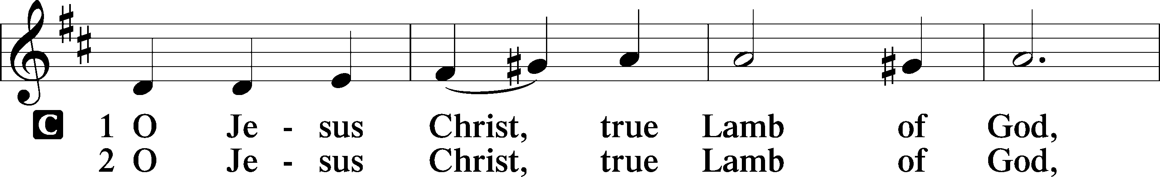
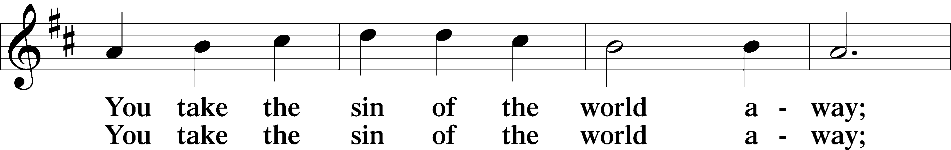
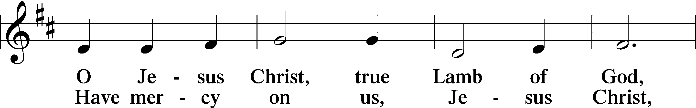
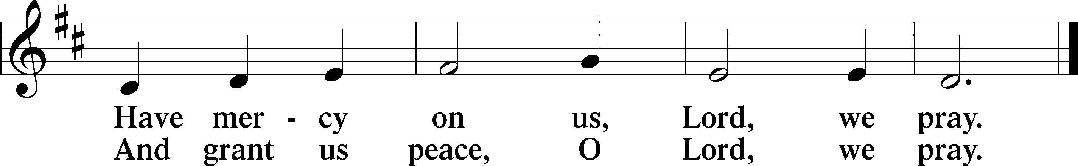

Sit

Distribution & Distribution Hymns

I Want to Walk as a Child of the Light LSB 411

What a Friend We Have in Jesus LSB 770

When all have communed, please stand for the blessing.

Post-Communion Canticle Nunc Dimittis LSB 211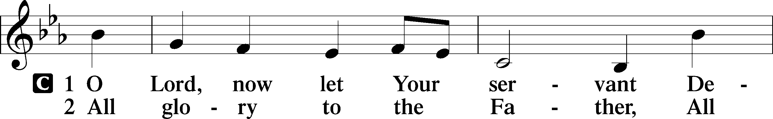
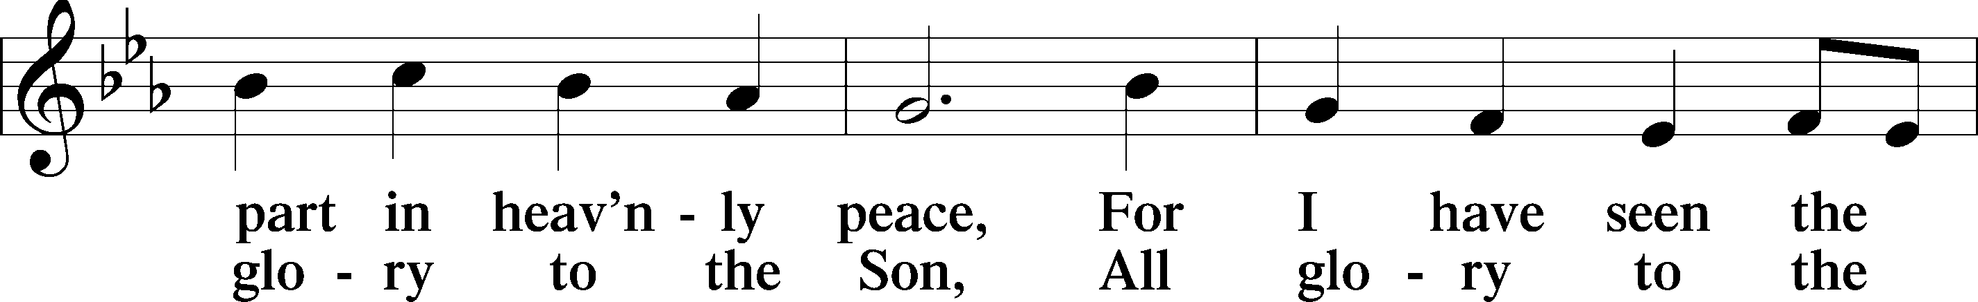
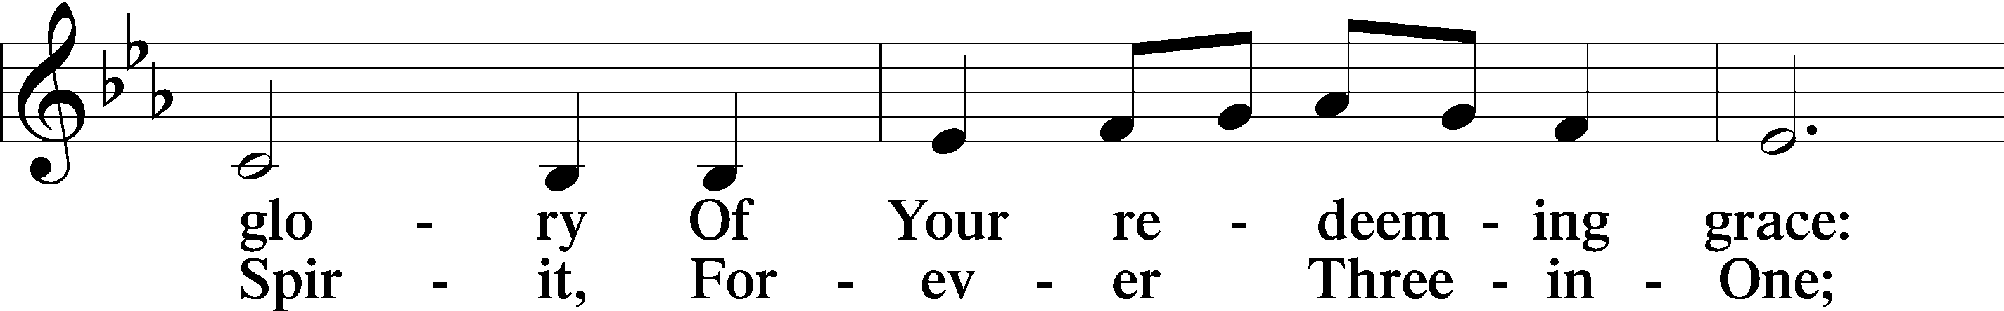
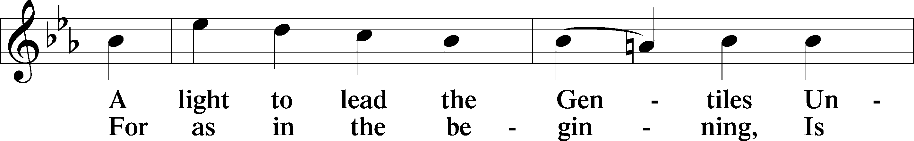
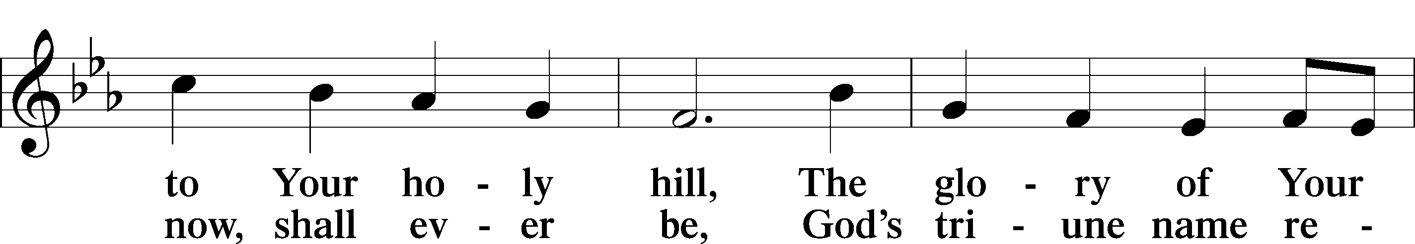
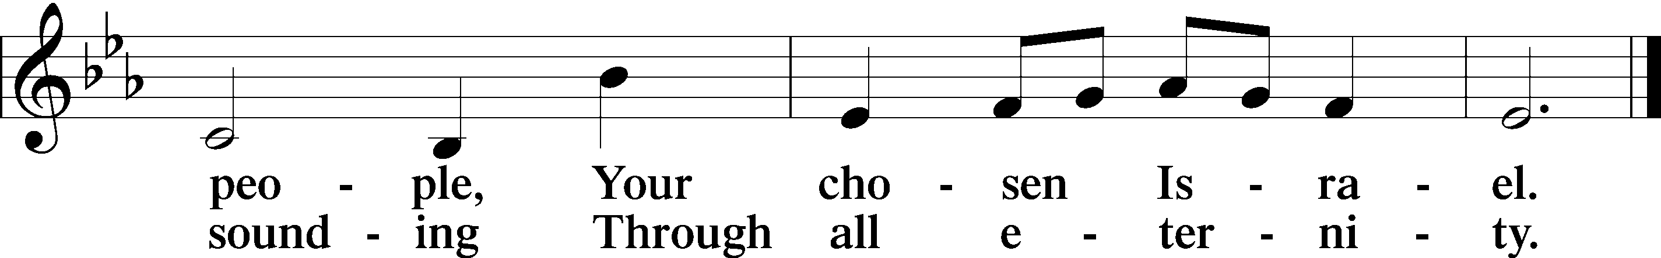

Post-Communion Collect
P Let us pray. Gracious God, our heavenly Father, You have given us a foretaste of the feast to come in the Holy Supper of Your Son’s body and blood. Keep us firm in the true faith throughout our days of pilgrimage that, on the day of His coming, we may, together with all Your saints, celebrate the marriage feast of the Lamb in His kingdom which has no end; through Jesus Christ, Your Son, our Lord, who lives and reigns with You and the Holy Spirit, one God, now and forever.

C Amen.

Benediction
P The LORD bless you and keep you. The LORD make His face shine on you and be gracious to you. The LORD lift up his countenance upon you and T give you peace.
C Amen.

Recessional Hymn Jesus Shall Reign LSB 832

Brief Silence

P Go in peace and serve the Lord! C Thanks be to God!

Soli Deo Gloria!

Special thanks to
Stanely Beckwith-Viola
David Alan Pierce-Violin

Acknowledgments Divine Service, Setting Four from Lutheran Service Book. Unless otherwise indicated, Scripture quotations are from the ESV® Bible (The Holy Bible, English Standard Version®), copyright © 2001 by Crossway, a publishing ministry of Good News Publishers. Used by permission. All rights reserved. Created by Lutheran Service Builder © 2018 Concordia Publishing House. Some songs CCLI license 3963284.

